# Project Creation in mbed IDE

1. Go to ARM MBED website( <https://www.mbed.com/en/> ) and sign up a new account.

Click on **Compiler** button to start the IDE



1. Add your board (NUCLEO-411RE) as the platform.

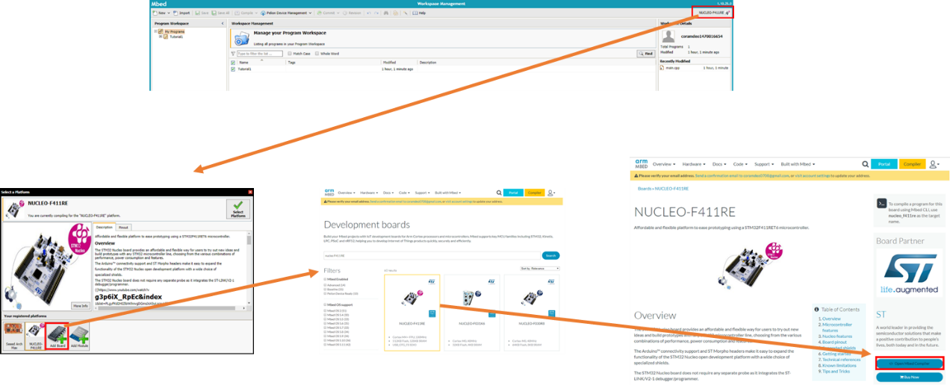

1. To create a new program, select **New**🡪**New Program**

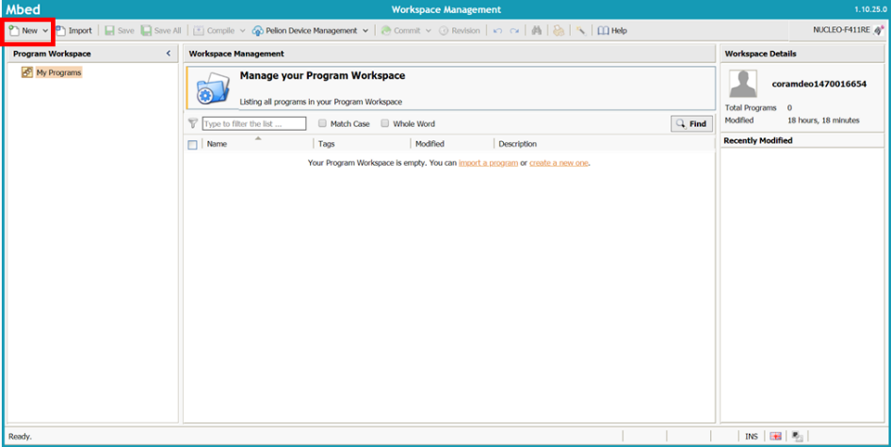

1. Check if the Platform is correctly selected your board.
2. Choose any template program offered by mbed. For this tutorial, choose ‘Blinky LED test for ST Nucleo board’.
3. Name the program as ‘Nucleo_blink_led’

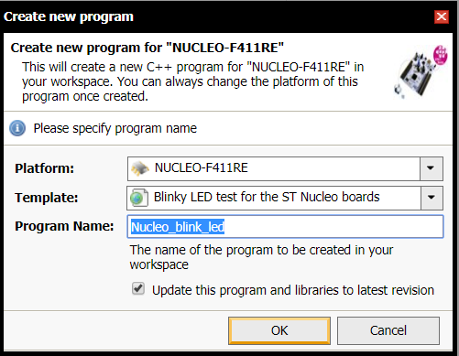

1. Compile your program (Ctrl+D).
2. If there is no compilation error, then ‘**.bin’ file will be downloaded on your PC.
3. Copy the file to the Flash Memory on the Nucleo board.

